
REQUEST FOR QUOTATION (GOODS) |  | 
SUPPLY CHAIN MANAGEMENT: PROCUREMENT
SCM-555 | Approved by Branch Manager: 01.02.2017 | Version: 10 | Page 1 of 33

QUOTATION NUMBER: GL11800867

DESCRIPTION: Back Bags Request: Ward 18, 87, 90, 91 Youth Event

CLOSING DATE: | 05 June 2018
CLOSING TIME: | 12:00 p.m.
SEND QUOTATION TO: | GL1.Quotations@capetown.gov.za

SUPPLIER
NAME of Company/Close Corporation or
Partnership / Joint Venture/ Consortium or
Sole Proprietor /Individual
TRADING AS (if different from above)

GENERAL QUOTATION INFORMATION

The standard Quotation Conditions, Special Conditions of Contract and General Conditions of Contract are not reproduced in this quotation document. These conditions must be downloaded from the City of Cape Town (CCT) website by following the links provided in the applicable parts of this document.

By submitting a quotation suppliers warrant that they have familiarised themselves with the content of the aforesaid conditions.

QUOTATION SUBMISSION : All returnable schedules as detailed on the document index must be sent to the number or address stated on the front cover of this document before closing time.
No late quotations will be accepted under any circumstances.

CCT REPRESENTATIVE Name:Sindiso Baliso / Shahieda Darries
Tel. No.: (021): 900 18 16 /900 1706
Email: Sindiso.Baliso@capetown.gov.za /
Shahieda.Darries@capetown.gov.za

INDEX
RETURNABLE SCHEDULES
(All schedules must be completed and returned by the supplier when submitting the offer)
1 | Details of Supplier
2 | Form of Offer
3 | Price Schedule
4 | Preference Schedule
5 | Declaration of Interest – State Employees
6 | Conflict of Interest Declaration
7 | Declaration of Supplier’s Past Supply Chain Management Practices
8 | Authorisation for the deduction of outstanding amounts owed to the City of Cape Town
9 | Certificate of Independent Quotation Determination
10 | Proof of Insurances / Insurance Broker’s Warranty
11 | Local Content used
IMPORTANT QUOTATION INFORMATION
(These parts need not be returned by the supplier when submitting the offer)
A | Project Specification
B | Quotation Conditions
C | Special Conditions of Contract
D | General Conditions of Contract

(1) DETAILS OF SUPPLIER

1.1 Type of Entity (Please tick one box)

 | Individual / Sole Proprietor |  |  |  | Close Corporation |  | Company
 | Partnership or Joint Venture or Consortium |  | Trust |  | Other: ……….......………..…………

1.2 Required Details (Please provide applicable details in full):

Name of Company / Close

Corporation or

Partnership / Joint Venture / Consortium or

Individual /Sole Proprietor
Trading as (if different from above)
Company / Close Corporation registration number (if applicable)
Postal address | Postal Code __________
Physical address  (Chosen domicilium citandi et executandi) | Postal Code __________
Contact details of the person duly authorised to represent the supplier | Name: Mr/Ms _  (Name & Surname)  Telephone:( ) Fax:( )  Cellular Telephone:  E-mail address: _
Business Partner (BP) number
Income tax number
VAT registration number
SARS Tax Compliance Status PIN
City of Cape Town Supplier Database Registration Number (See Conditions of Quotation)
National Treasury Central Supplier Database registration number (See Conditions of Tender)

(2) FORM OF OFFER

QUOTATION NUMBER: GL11800867

DESCRIPTION: Back Bags Request: Ward 18, 87, 90, 91 Youth Event

Required Details (Please provide applicable details in full):

Name of Entity*
(“the SUPPLIER”)
Trading as (if different from above)

AND WHO IS represented herein by: (full names of signatory) _
duly authorised to act on behalf of the supplier in his capacity as: (title/ designation)
HEREBY AGREES THAT by signing the Form of Offer, the supplier:
- confirms that it has examined the documents listed in the Index (including Schedules and Annexures) and has accepted all the Quotation Conditions;
- confirms that it has satisfied itself as to the correctness and validity of the quotation offer; that the price(s) and rate(s) offered cover all the goods and/or services specified in the quotation documents; that the price(s) and rate(s) cover all its obligations and accepts that any mistakes regarding price(s), rate(s) and calculations will be at its own risk;
- offers to supply all or any of the goods and/or render all or any of the services described in the quotation document to the CCT in accordance with the:
  - terms and conditions stipulated in this contract document;
  - specifications stipulated in this quotations document; and
  - at the prices as set out in the Price Schedule.
- accepts full responsibility for the proper execution and fulfilment of all obligations and conditions devolving on it in terms of the Contract.

_*_______________________________
Signature(s)

_________________________________
Print name(s):
On behalf of the supplier (duly authorised)

_________________________________
Date

(3) PRICE SCHEDULE

Item No | Specification | Delivery period | Unit of measure | QTY | Price per unit  (excl VAT) | Total (excl VAT)* | Brand/Model / Specification
1 | Explorer Backpack:  Ward 18  Explorer Backpack  Material: 1680D Nylon  Size: 46 x 32 x 20cm (H x L x W)  Colour: Black  NB: With Artwork – Ward 18 Youth Event 2018  #FutureLeaders  With youth logo  As per artwork approval |  |  | 150 (for each ward)
 | Explorer Backpack:  Ward 87  Explorer Backpack  Material: 1680D Nylon  Size: 46 x 32 x 20cm (H x L x W)  Colour: Black  NB: With Artwork – Ward 87 Youth Event 2018  #FutureLeaders  With youth logo  As per artwork approval |  |  | 150 (for each ward)
 | Explorer Backpack:  Ward 90  Explorer Backpack  Material: 1680D Nylon  Size: 46 x 32 x 20cm (H x L x W)  Colour: Black  NB: With Artwork – Ward 90 Youth Event 2018  #FutureLeaders  With youth logo  As per artwork approval |  |  | 150 (for each ward)
2 | Explorer Backpack:  Ward 91  Explorer Backpack  Material: 1680D Nylon  Size: 46 x 32 x 20cm (H x L x W)  Colour: Black  NB: With Artwork – Ward 91 Youth Event 2018  #FutureLeaders  With youth logo  As per artwork approval |  |  | 150 (for each ward)

Pricing Instructions:

  - State the rates and prices in Rand unless instructed otherwise in the quotation conditions.
  - Include in the rates, prices, and the quoted total of the prices (if any) all duties, taxes (except Value Added Tax (VAT)), and other levies payable by the successful supplier, such duties, taxes and levies being those applicable 14 days before the closing time stated in the General Quotation Information.
  - All prices quoted must include all expenses, disbursements and costs (e.g. transport, accommodation etc.) that may be required for the execution of the supplier’s obligations in terms of the Contract, and shall cover the cost of all general risks, liabilities and obligations set forth or implied in the Contract as well as overhead charges and profit (in the event that the quotation is successful). All prices quoted will be final and binding.
  - All prices shall be quoted in accordance with the units specified in this schedule.
  - Where a value is given in the Quantity column, a Rate and Price (the product of the Quantity and Rate) is required to be inserted in the relevant columns.
  - The successful supplier is required to perform all tasks listed against each item. The supplier must therefore submit prices/rates on all items as per the section in the Price Schedule.
  - State brand / model or detailed specification of offered product in the last column of the price schedule. If insufficient space is provided in the price schedule, suppliers can attach such information to their quotations whilst ensuring such additional information is correctly referenced to the applicable items.

(4) PREFERENCE SCHEDULE

1 Definitions
The following definitions shall apply to this schedule:
All applicable taxes: Includes value-added tax, pay as you earn, income tax, unemployment insurance fund contributions and skills development levies.
Applicable Code: Shall be either the Amended Codes of Good Practise (published on 11 October 2013) or Sector Specific Codes as indicated in the tender conditions
B-BBEE: Broad-based black economic empowerment as defined in section 1 of the Broad-Based Black Economic Empowerment Act.
B-BBEE status level of contributor: The B-BBEE status of an entity in terms of a code of good practice on black economic empowerment issued in terms of section 9(1) of the Broad-Based Black Economic Empowerment Act.
Bid (Quotation): A written offer in a prescribed or stipulated form in response to an invitation by an organ of state for the provision of services, works or goods, through price quotations, advertised competitive bidding processes or proposals.
Black Designated Groups: The meaning assigned to it in the codes of good practice issued in terms of section 9(1) of the Broad-Based Black Economic Empowerment Act, 2003, (Act 53 of 2003).
Black People: The meaning assigned to it in section 1 of the Broad-Based Black Economic Empowerment Act.
Broad-Based Black Economic Empowerment Act: The Broad-Based Black Economic Empowerment Act, Act 53 of 2003.
Consortium or Joint Venture: An association of persons for the purpose of combining their expertise, property, capital, efforts, skill and knowledge in an activity for the execution of a contract.
Contract The agreement that results from the acceptance of a bid by an organ of state.
Co-operative: A co-operative registered in terms of section 7 of the Co-operatives Act, 2005 (Act no. 14 of 2005).
Designated Group: Black designated groups, black people, women, people with disabilities or small enterprises as defined in section 1 of the National Small Enterprises Act, 1996 (act no. 102 of 1996)
Designated Sector: A sector, sub-sector or industry or product that has been designated in terms of any relevant regulation of the Preferential Procurement Regulations, 2017.
Exempted Micro Enterprise (EME): An exempted micro enterprise in terms of a code of good practice on black economic empowerment issued in terms of section 9(1) of the Broad-Based Black Economic Empowerment Act.
Firm Price: The price that is only subject to adjustments in accordance with the actual increase or decrease resulting from the change, imposition, or abolition of customs or excise duty and any other duty, levy, or tax, which, in terms of the law or regulation, is binding on the contractor and demonstrably has an influence on the price of any supplies, or the rendering costs of any service, for the execution of the contract.
Functionality: The ability of a bidder to provide goods or services in accordance with specifications as set out in the quotation documents..
Military Veteran: The meaning assigned to it in section 1 of the Military Veterans Act, 2011 (Act No. 18 of 2011).
National Treasury: The meaning assigned to it in section 1 of the Public Finance Management Act, 1999 (Act No. 18 of 1999.
Non-firm prices: All prices other than “firm” prices.
Person: Includes a juristic person.
People with disabilities: The meaning assigned to it in section 1 of the Employment equity Act, 1998 (Act No. 55 of 1998).
Price: Includes all applicable taxes less unconditional discounts.
Proof of B-BBEE status level of contributor: The B-BBEE status level certificate issued by an authorised body or person, a sworn affidavit as prescribed by the B-BBEE Codes of good Practice or any other requirement prescribed in terms of the Broad-Based Black Economic Empowerment Act.
Qualifying Small Enterprise (QSE): A qualifying small enterprise in terms of a code of good practice on black economic empowerment issued in terms of section 9(1) of the Broad-Based Black Economic Empowerment Act.
Rand Value: means the total estimated value of a contract in Rand, calculated at the time of bid invitations.
Rural Area: A sparsely populated area in which people farm or depend on natural resources, including villages and small towns that are dispersed through the area or an area including a large settlement which depends on migratory labour and remittances and government social grants for survival, and may have a traditional land tenure system.
Stipulated Minimum Threshold: The minimum threshold stipulated in terms of any relevant regulation of the Preferential Procurement Regulations, 2017.
Sub-contract: The primary contractor’s assigning, leasing, making out work to, or employing, another person to support such primary contractor in the execution of part of a project in terms of the contract.
The Act: The Preferential Procurement Policy Framework Act, 2000 (Act No 5 of 2000).
Total Revenue: Bears the same meaning assigned to this expression in the Codes of Good Practice on Black Economic Empowerment, issued in terms of section 9(1) of the Broad-Based Black Economic Empowerment Act and promulgated in the Government Gazette on 9 February 2007.
Township: An urban living area that at any time from the late 19th century until 27 April 1994, was reserved for black people, including areas developed for historically disadvantaged individuals post 27 April 1994.
Treasury: The meaning assigned to it in section 1 of the Public Finance Management Act, 1999 (Act No. 18 of 1999).
Trust: The arrangement through which the property of one person is made over or bequeathed to a trustee to administer such property for the benefit of another person.
Trustee: Any person, including the founder of a trust, to whom property is bequeathed in order for such property to be administered for the benefit of another person.
Youth: The meaning assigned to it in section 1 of the National Youth Development Agency Act, 2008 (Act No. 54 of 2008).

2 Conditions associated with the granting of preferences
A supplier that is granted a preference undertakes to:
- accept that the number of preference points allocated will be based on the B-BBEE status level of contributor of the supplier as at the closing date for submission of quotation offers;
- not sub-contract more than 25% of the value of the contract to sub-contractors that do not have an equal or higher B-BBEE status level of contributor than the supplier, unless the intended sub-contractors are exempted micro enterprises that have the capability and ability to execute the sub-contract works or unless otherwise declared in terms of Section 5 below;
- accept that a contract may not be awarded if the price offered is not market related;
- accept the sanctions set out in Section 3 below should Condition 2(2) be breached, or should the bidder have submitted any false information regarding its B-BBEE status level of contributor, local production and content, or any other matter required in terms of this bid that will affect, or has affected the bid evaluation;
- accept that, in order to qualify for preference points, it is the responsibility of the supplier to submit documentary proof of its BBBEE level of contribution in accordance with the Codes of Good Practise, 2013, to the CCT at the Supplier Management Unit located within the Tender Distribution Office, 2nd Floor (Concourse Level), Civic Centre, 12 Hertzog Boulevard, Cape Town (Tel 021 400 9242/3/4/5);
- accept that, further to 5) above, Consortiums/Joint Ventures will qualify for preference points, provided that the entity submits the relevant certificate/scorecard in terms of the Preferential Procurement Regulations, 2017. Note that, in the case of unincorporated entities, a verified scorecard in the name of the consortium/Joint Venture must be submitted with the quotation (attached to this schedule);
- accept that if it is found that, in the performance of the contract, the participation of the various partners in a Consortium/ Joint Venture differs substantially from that upon which the consolidated scorecard submitted in terms of 5) above was based, and the impact of which is that the Joint Venture would not have been awarded the contract in terms of the actual B-BBEE level of contribution achieved by the Joint Venture, then a financial penalty shall be applied (in addition to any other remedies that the CCT may have) in accordance with Section 3 below;
- accept that suppliers are required to be registered on the City of Cape Town’s Supplier Database prior to the acceptance of quotations in order to qualify for preference points. The CCT will verify the B-BBEE level of contributor of the supplier as at the closing date for submission of quotation offers, to determine the number of preference points to be awarded to the supplier. In the case of Consortiums/Joint Ventures which quote as unincorporated entities, a verified scorecard submitted with the quotation and valid as at the closing date will be used to determine the number of preference points to be awarded to the supplier;
- accept that, notwithstanding 8) above, a supplier will not be awarded points for B-BBEE status level of contributor if he indicates in his quotation that he intends sub-contracting more than 25% of the value of the contract to sub-contractors that do not qualify for at least the points that the supplier qualifies for unless the intended sub-contractors are exempted micro enterprises that have the capability and ability to execute the sub-contract works;
- accept that any subcontracting arrangements after the award of the quotation may only be entered into upon the prior approval of the City of Cape Town; and
- immediately inform the City of Cape Town of any change that may affect the bidder’s B-BBEE level of contribution upon which preference points will be or have been allocated.

3 Sanctions relating to breaches of preference conditions
The sanctions for breaching the conditions associated with the granting of preferences are:
1) disqualify the supplier from the quotation process;
2) recover costs, losses or damages the CCT has incurred or suffered as a result of the supplier’s or contractor’s conduct;
3) cancel the contract in whole or in part and claim any damages which the CCT has suffered as a result of having to make less favourable arrangements due to such cancellation;
4) restrict the supplier, its shareholders and directors, or only the shareholders and directors who acted on a fraudulent basis, from obtaining business from the CCT for a period not exceeding 10 years, after the audi alteram partem (hear the other side) rule has been applied and inform the National Treasury accordingly;
5) forward the matter for criminal prosecution; and/or
6) financial penalties payable to the CCT, as set out below.

Financial penalty for breach of Condition 2 in Section 2 above:
The penalty to be applied for sub-contracting more than 25% of the value of the contract to sub-contractors that do not qualify for at least the preference points that the supplier qualified for (unless so declared or proven to be beyond the control of the supplier, or the sub-contractors are EMEs that have the capability and ability to execute the sub-contract works) shall be as provided for in the following formula:
Penalty = 0.5 x E(%) x P*
where:
E = The value of work (excluding VAT) executed by sub-contractors that do not qualify for at least the preference points that the supplier qualified for, expressed as a percentage of P*, less 25%
P* = Value of the contract

Financial penalty for breach in terms of condition 6 in Section 2 above:
The penalty to be applied where, in the performance of the contract, the participation of the various partners in a Consortium/ Joint Venture differs substantially from that upon which the consolidated scorecard submitted in terms of 5) in Section 2 above was based, and the impact of which is that the Joint Venture would not have been awarded that contract in terms of the actual B-BBEE level of contribution achieved by the Joint Venture, shall be as provided for in the following formula:
Penalty = 5/100 x (B-BBEEª – B-BBEE^{t}) x P*
where:
B-BBEEª = The B-BBEE level of contribution that is achieved, determined in accordance with the actual participation of the Joint Venture partners in the performance of the contract
B-BBEE^{t} = The B-BBEE level of contribution that was used to determine the number of preference points granted to the Joint Venture at the time of quotation evaluation
P* = Value of the contract

Financial penalty for breach in terms of condition 10 in Section 2 above:
The penalty to be applied where the supplier fails to disclose subcontracting arrangement after the award of the quotation is up to a maximum of 10% of the value of the contract.

4 Level of Contribution in respect of enterprise status or structure of the bidding entity (the supplier)
In the interest of transparency, suppliers are required to complete Table 1: Level of Contribution below.

Table 1: Level of Contribution
Type of B-BBEE Contributor | Status (tick box(es) below as applicable)
Exempted Micro Enterprise (EME), 100% black-owned
Exempted Micro Enterprise (EME), at least 51% but less than 100% black-owned
Exempted Micro Enterprise (EME), less than 51% black-owned
Qualifying Small Enterprise (QSE), 100% black-owned
Qualifying Small Enterprise (QSE), at least 51% but less than 100% black-owned
Qualifying Small Enterprise (QSE), less than 51% black-owned
Verified B-BBEE contributor
B-BBEE Status Level of Contributor¹
Non-compliant contributor
¹ If it is indicated that the company/firm/entity is a verified B-BBEE contributor, then the verified status level of contributor must be inserted in the box provided (insert a number from 1 to 8 as applicable)

5 Declarations
1) With reference to Condition 8 in Section 2 above, the supplier declares that:
I/we hereby forfeit my preference points because I /we DO intend sub-contracting more than 25% of the value of the contract to sub-contractors that do not qualify for at least the points that I/we as supplier qualify for or are not exempted micro enterprises that have the capability and ability to execute the sub-contract works
Note:
Bidders who do not tick this box will be allocated preference points but the sanctions relating to breaches of preference conditions in Section 3 will be applicable if the bidder contravenes the conditions in Section 2.
2) The undersigned, who warrants that he/she is duly authorized to do so on behalf of the supplier, hereby certifies that the preference claimed based on the B-BBEE status level of contribution indicated in Table 1, qualifies the supplier, subject to condition 8 in Section 2 above, for such preference claimed, and acknowledges that:
- the information furnished is true and correct;
- the preference claimed is in accordance with the conditions of this schedule;
- the supplier may be required to furnish documentary proof to the satisfaction of the CCT that the BBBEE level of contributor as at the closing date is correct; and
iv) he/she understands the conditions under which preferences are granted, and confirms that the supplier will satisfy the conditions pertaining to the granting of preferences.

________________________________ _________________________________
Signature Date

For official use.
SIGNATURE OF CITY OFFICIALS AT QUOTATION OPENING
1. | 2. | 3.

________________________________
Name (PRINT)
(For and on behalf of the Supplier (duly authorised))

(5) DECLARATION OF INTEREST – STATE EMPLOYEES

- No bid will be accepted from persons in the service of the state¹.
- Any person, having a kinship with persons in the service of the state, including a blood relationship, may make an offer or offers in terms of this invitation to bid. In view of possible allegations of favouritism, should the resulting bid, or part thereof, be awarded to persons connected with or related to persons in service of the state, it is required that the supplier or their authorised representative declare their position in relation to the evaluating/adjudicating authority.

3 In order to give effect to the above, the following questionnaire must be completed and submitted with the bid.

3.1 Full Name of supplier or his or her representative:……………………………………………..

3.2 Identity Number: ………………………………………………………………………………….

3.3 Position occupied in the Company (director, trustee, shareholder²):………………………..

3.4 Company or Close Corporation Registration Number: ……………………………………………

3.5 Tax Reference Number:…………………………………………………………………………

3.6 VAT Registration Number: ……………………………………………………………………

3.7 The names of all directors / trustees / shareholders members, their individual identity numbers and state employee numbers must be indicated in paragraph 4 below.

3.8 Are you presently in the service of the state? YES / NO

3.8.1 If yes, furnish particulars. ….…………………………………………………………………………………………..

…………………………………………………………………………………………………….

3.9 Have you been in the service of the state for the past twelve months? YES / NO

3.9.1 If yes, furnish particulars
.………………………...……………………………………………….…………………………………………………………

……………………………………………………………………………………………………………………………………

3.10 Do you have any relationship (family, friend, other) with persons in the service of the state and who may be involved with the evaluation and or adjudication of this bid? YES / NO

3.10.1 If yes, furnish particulars.
……………………………………………………………………………………………………………………………………

……………………………………………………………………………………………………………………………………

3.11 Are you, aware of any relationship (family, friend, other) between any other supplier and any persons in the service of the state who may be involved with the evaluation and or adjudication of this bid? YES / NO

3.11.1 If yes, furnish particulars
…………………………………………………………………………………………………………………………………

……………………………………………………………………………………………………………………………………

3.12 Are any of the company’s directors, trustees, managers, principle shareholders or stakeholders in service of the state? YES / NO

3.12.1 If yes, furnish particulars.……………………………………………………………………………….

3.13 Are any spouse, child or parent of the company’s directors, trustees, managers, principle shareholders or stakeholders in service of the state? YES / NO

3.13.1 If yes, furnish particulars.
……………………………………………………………………………………………………………………………………

……………………………………………………………………………………………………………………………………

13.4 Do you or any of the directors, trustees, managers, principle shareholders, or stakeholders of this company have any interest in any other related companies or business whether or not they are bidding for this contract? YES / NO

3.14.1 If yes, furnish particulars:
……………………………………………………………………………………………………………………………………

……………………………………………………………………………………………………………………………………

4. Full details of directors / trustees / members / shareholders.

Full Name | Identity Number | State Employee Number

The supplier hereby certifies that the information set out in this schedule and/or attached thereto is true and correct, and acknowledges that failure to properly and truthfully complete this schedule may result in the quotation being disqualified, and/or (in the event that the supplier is successful) the cancellation of the contract, restriction of the supplier or the exercise by the CCT of any other remedies available to it.

________________________________________ ______________________________________
Signature Date

________________________________________
Name (PRINT)
(For and on behalf of the supplier, duly authorised)

¹MSCM Regulations: “in the service of the state” means to be –

- a member of –
  - any municipal council;
  - any provincial legislature; or
  - the national Assembly or the national Council of provinces;

- a member of the board of directors of any municipal entity;
- an official of any municipality or municipal entity;
- an employee of any national or provincial department, national or provincial public entity or constitutional institution within the meaning of the Public Finance Management Act, 1999 (Act No.1 of 1999);
- a member of the accounting authority of any national or provincial public entity; or
- an employee of Parliament or a provincial legislature.

² Shareholder” means a person who owns shares in the company and is actively involved in the management of the company or business and exercises control over the company.

(6) CONFLICT OF INTEREST DECLARATION

- The supplier shall declare whether it has any conflict of interest in the transaction for which the quotation is submitted. (Mark the appropriate box with ‘X’)
YES | NO

If yes, the supplier is required to set out the particulars in the table below:

- The supplier shall declare whether it has directly or through a representative or intermediary promised, offered or granted:

2.1 any inducement or reward to the City of Cape Town for or in connection with the award of this contract; or

2.2 any reward, gift, favour or hospitality to any official or any other role player involved in the implementation of the supply chain management policy. (Mark the appropriate box with ‘X’)

YES | NO

If yes, the supplier is required to set out the particulars in the table below:

Should the supplier be aware of any corrupt or fraudulent transactions relating to the procurement process of the City of Cape Town, he or she must please contact the following:

the City’s anti-corruption hotline at 0800 32 31 30 (toll free)

The supplier hereby certifies that the information set out in this schedule and/or attached thereto is true and correct, and acknowledges that failure to properly and truthfully complete this schedule may result in the quotation being disqualified, and/or (in the event that the supplier is successful) the cancellation of the contract, restriction of the supplier or the exercise by the CCT of any other remedies available to it

________________________________ _____________________________
Signature Date

________________________________
Name (PRINT)
(For and on behalf of the supplier (duly authorised))

(7) DECLARATION OF SUPPLIER’S PAST SUPPLY CHAIN MANAGEMENT PRACTICES

Where the entity submitting the quotation is a partnership/consortium/joint venture, each party to the partnership/consortium/joint venture must sign a declaration in terms of the Municipal Finance Management Act, Act 56 0f 2003, and attach it to this schedule.

- The bid of any supplier may be rejected if that supplier or any of its directors/members have:

  - abused the municipality’s / municipal entity’s supply chain management system or committed any improper conduct in relation to such system;
  - been convicted for fraud or corruption during the past five years;
  - willfully neglected, reneged on or failed to comply with any government, municipal or other public sector contract during the past five years; or
  - been listed in the Register for Tender Defaulters in terms of section 29 of the Prevention and Combating of Corrupt Activities Act (No 12 of 2004).

- In order to give effect to the above, the following questionnaire must be completed and submitted with the bid.

Item | Question | Yes |  | No
4.1 | Is the supplier or any of its directors listed on the National Treasury’s Database of Restricted Suppliers as companies or persons prohibited from doing business with the public sector?  (Companies or persons who are listed on this Database were informed in writing of this restriction by the Accounting Officer/Authority of the institution that imposed the restriction after the audi alteram partem rule was applied).  The Database of Restricted Suppliers now resides on the National Treasury’s website(www.treasury.gov.za) and can be accessed by clicking on its link at the bottom of the home page. | Yes |  | No
4.1.1 | If so, furnish particulars:
4.2 | Is the supplier or any of its directors listed on the Register for Quotation Defaulters in terms of section 29 of the Prevention and Combating of Corrupt Activities Act (No 12 of 2004)?  The Register for Quotation Defaulters can be accessed on the National Treasury’s website (www.treasury.gov.za) by clicking on its link at the bottom of the home page. | Yes | No
4.2.1 | If so, furnish particulars:

4.3 | Was the supplier or any of its directors convicted by a court of law (including a court of law outside the Republic of South Africa) for fraud or corruption during the past five years? | Yes | No
4.3.1 | If so, furnish particulars:
Item | Question | Yes | No
4.4 | Does the supplier or any of its directors owe any municipal rates and taxes or municipal charges to the municipality / municipal entity, or to any other municipality / municipal entity, that is in arrears for more than three months? | Yes | No
4.4.1 | If so, furnish particulars:
4.5 | Was any contract between the supplier and the municipality / municipal entity or any other organ of state terminated during the past five years on account of failure to perform on or comply with the contract? | Yes | No
4.7.1 | If so, furnish particulars:

The supplier hereby certifies that the information set out in this schedule and/or attached thereto is true and correct, and acknowledges that failure to properly and truthfully complete this schedule may result in the quotation being disqualified, and/or (in the event that the supplier is successful) the cancellation of the contract, restriction of the supplier or the exercise by the CCT of any other remedies available to it

___________________________________ ___________________________________
Signature
Print name: Date
On behalf of the supplier (duly authorised)

(8) AUTHORISATION FOR THE DEDUCTION OF OUTSTANDING AMOUNTS OWED TO THE CITY OF CAPE TOWN

QUOTATION NO. GL11800867

DESCRIPTION: Back Bags Request: Ward 18, 87, 90, 91 Youth Event

To: THE CITY MANAGER, CITY OF CAPE TOWN

From: _______________________________________________________________
(Name of bidder)

The bidder:

- hereby acknowledges that according to SCM Regulation 38(1)(d)(i) the City Manager may reject the quotation of the bidder if any municipal rates and taxes or municipal service charges owed by the bidder (or any of its directors/members/partners) to the CCT, or to any other municipality or municipal entity, are in arrears for more than 3 (three) months; and
- therefore hereby agrees and authorises the CCT to deduct the full amount outstanding by the Bidder or any of its directors/members/partners from any payment due to the bidder; and
- confirms the information as set out in the tables below for the purpose of giving effect to b) above;
- The bidder hereby certifies that the information set out in this schedule and/or attached hereto is true and correct, and acknowledges that failure to properly and truthfully complete this schedule may result in steps being taken against the bidder, the quotation being disqualified, and/or (in the event that the bidder is successful) the cancellation of the contract and/or steps in terms of the abuse of the Supply Chain Management Policy.

Physical Business address of the Bidder | Municipal Account number(s)

If there is not enough space for all the names, please attach the additional details to the Quotation Document

Name of Director / Member / Partner | Identity Number | Physical residential address of Director / Member / Partner | Municipal  Account number(s)

___________________________________ ___________________________________
Signature
Print name: Date
On behalf of the bidder (duly authorised)

(9) CERTIFICATE OF INDEPENDENT QUOTATION DETERMINATION

I, the undersigned, in submitting this Quotation Number GL11800867
Description: Back Bags Request: Ward 18, 87, 90, 91 Youth Event in response to the call for quotations made by the City of Cape Town, do hereby make the following statements, which I certify to be true and complete in every respect.

I certify, on behalf of: ___________________________________________________________ (name of supplier)

That:
1. I have read and I understand the contents of this Certificate;
2. I understand that this quotation will be disqualified if this Certificate is found not to be true and complete in every respect;
3. I am authorised by the supplier to sign this Certificate, and to submit this quotation, on behalf of the supplier;
4. Each person whose signature appears on this quotation has been authorised by the supplier to determine the terms of, and to sign the quotation on behalf of the supplier;
5. For the purposes of this Certificate and this quotation, I understand that the word ‘competitor’ shall include any individual or organisation, other than the supplier, whether or not affiliated with the supplier, who:
(a) has been requested to submit a quotation in response to this call for quotations;
(b) could potentially submit a quotation in response to this call for quotations, based on their qualifications, abilities or experience; and
(c) provides the same goods and services as the supplier and/or is in the same line of business as the supplier.
6. The supplier has arrived at this quotation independently from and without consultation, communication, agreement or arrangement with any competitor. However, communication between partners in a joint venture or consortium* will not be construed as collusive bidding.
7. In particular, without limiting the generality of paragraphs 5 and 6 above, there has been no consultation, communication, agreement or arrangement with any competitor regarding:
(a) prices;
(b) geographical area where product or service will be rendered (market allocation);
(c) methods, factors or formulas used to calculate prices;
(d) the intention or decision to submit or not to submit a quote;
(e) the submission of a quotation which does not meet the specifications and conditions of the quotation; or
(f) submitting a quotation with the intention not to win the contract.
8. In addition, there have been no consultations, communications, agreements or arrangements with any competitor regarding the quality, quantity, specifications and conditions or delivery particulars of the products or services to which this call for quotation relates.
9. The terms of this quotation have not been, and will not be, disclosed by the supplier, directly or indirectly, to any competitor, prior to the date and time of the official quotation opening or of the awarding of the contract.
10. I am aware that, in addition and without prejudice to any other remedy provided to combat any restrictive practices related to quotations and contracts, quotations that are suspicious will be reported to the Competition Commission for investigation and possible imposition of administrative penalties in terms of section 59 of the Competition Act, Act 89 of 1998, and/or may be reported to the National Prosecuting Authority (NPA) for criminal investigation, and/or may be restricted from conducting business with the public sector for a period not exceeding ten (10) years in terms of the Prevention and Combating of Corrupt Activities Act, Act 12 of 2004, or any other applicable legislation.

________________________________ _____________________________
Signature Date

_____________________________
Name (PRINT)
(For and on behalf of the Supplier (duly authorised))

(* Consortium: a Joint Venture or Consortium means an association of persons for the purpose of combining their expertise, property, capital, efforts, skill and knowledge in an activity for the execution of a contract.)

(10) PROOF OF INSURANCES / INSURANCE BROKER’S WARRANTY

Proof of Insurances

Suppliers must either attach proof of the following insurances required in terms of the General and Special Conditions of Contract to this schedule or submit an Insurance Broker’s Warranty (see attaced pro-forma on following page) attesting to their compliance herewith:

- Public Liability Insurance
- Motor Vehicle Insurance
- Registration or insurance in terms of the Compensation for Occupational Injuries and Diseases Act, Act 130 of 1993.

Failure to submit proof of all the above, either with this quotation or within any further time for submission stated in a written request from the CCT, will result in the Supplier’s quotation being declared as non-responsive.

Insurance Broker’s Warranty (Pro Forma)

Logo

Letterhead of supplier’s Insurance Broker

Date:

CITY OF CAPE TOWN
City Manager
Civic Centre
12 Hertzog Boulevard
Cape Town
8000

Dear Sir

QUOTATION NO.: GL11800867

QUOTATION DESCRIPTION: Back Bags Request: Ward 18, 87, 90, 91 Youth Event

NAME OF SUPPLIER: :

I, the undersigned, do hereby confirm and warrant that all the insurances required in terms of the abovementioned contract have been issued and/or in the case of blanket/umbrella policies, have been endorsed to reflect the interests of the CITY OF CAPE TOWN with regard to the abovementioned contract, and that all the insurances and endorsements, etc, are all in accordance with the requirements of the contract.

I furthermore confirm that all premiums in the above regard have been paid.

Yours faithfully

Signed:

For: (Supplier’s Insurance Broker)

(11) LOCAL CONTENT DECLARATION / ANNEXURE C

DECLARATION CERTIFICATE FOR LOCAL PRODUCTION AND CONTENT FOR DESIGNATED SECTORS

Preamble

This declaration is based on and replaces Municipal Bid Document 6.2 (MBD 6.2).
The amendments made to the MBD 6.2 document have been necessary to clarify this standard document as it relates to local production and content in the Electrical and Telecom Cable sector.

Before completing this declaration, bidders must study the General Conditions, Definitions, Directives applicable in respect of Local Content as prescribed in the Preferential Procurement Regulations, 2017 and the South African Bureau of Standards (SABS) approved technical specification number SATS 1286:2011 (Edition 1) and the Guidance on the Calculation of Local Content together with the Local Content Declaration Templates [Annex C (Local Content Declaration: Summary Schedule), D (Imported Content Declaration: Supporting Schedule to Annex C) and E (Local Content Declaration: Supporting Schedule to Annex C)].

Documents listed herein are downloadable from the dti’s official website, http://www.thedti.gov.za.

This schedule must be completed by suppliers and returned with their quotation at the closing date and time for this quotation.

- General Conditions

  - Preferential Procurement Regulations, 2017 (Regulation 8) makes provision for the promotion of local production and content.

  - Regulation 8(1) prescribes that in the case of designated sectors, where in the award of bids where local production and content is of critical importance, such bids must be advertised with the specific bidding condition that only locally produced goods, services or works or locally manufactured goods, with a stipulated minimum threshold for local production and content will be considered.

  - The designated sector Textiles, Clothing, Leather and Footwear is applicable to items quoted for as detailed in Annexure C and all cables quoted for these items must comply with the requirements in respect of the local production and content legislation.

  - A person awarded a contract in relation to a designated sector, may not sub-contract in such a manner that the local production and content of the overall value of the contract is reduced to below the stipulated minimum threshold.

  - The local content (LC) expressed as a percentage of the bid price must be calculated in accordance with the SABS approved technical specification number SATS 1286: 2011 as follows:

LC = [1- x / y] *100

Where
x is the imported content in Rand
y is the bid price in Rand excluding value added tax (VAT)

Prices referred to in the determination of x must be converted to Rand (ZAR) by using the exchange rate published by ABSA Bank at close of business on the date of advertisement of the bid as required in paragraph 4.1 below.

The SABS approved technical specification number SATS 1286:2011 is accessible on http://www.thedti.gov.za/industrial_development/ip.jsp at no cost.

  - A bid will be disqualified/declared non-responsive if this Declaration Certificate and Annex C (Local Content Declaration: Summary Schedule) are not submitted as part of the bid documentation.

DECLARATION CERTIFICATE FOR LOCAL PRODUCTION AND CONTENT FOR DESIGNATED SECTORS (Cont’d)

- Definitions

  - “bid” includes written price quotations, advertised competitive bids or proposals;

  - “bid price” price offered by the supplier, excluding value added tax (VAT);

  - “contract” means the agreement that results from the acceptance of a bid by an organ of state;

  - “designated sector” means a sector, sub-sector or industry that has been designated by the Department of Trade and Industry (dti) in line with national development and industrial policies for local production, where only locally produced services, works or goods or locally manufactured goods meet the stipulated minimum threshold for local production and content;

  - “duly sign” means a Declaration Certificate for Local Content that has been signed by the Chief Financial Officer or other legally responsible person nominated in writing by the Chief Executive, or senior member / person with management responsibility(close corporation, partnership or individual) as per Returnable Schedule 1.

  - “imported content” means that portion of the bid price represented by the cost of components, parts or materials which have been or are still to be imported (whether by the supplier or its subcontractors) and which costs are inclusive of the costs abroad (this includes labour and intellectual property costs), plus freight and other direct importation costs, such as landing costs, dock duties, import duty, sales duty or other similar tax or duty at the South African port of entry;

  - “local content” means that portion of the bid price which is not included in the imported content, provided that local manufacture does take place;

  - “stipulated minimum threshold” means that portion of local production and content as determined by the Department of Trade and Industry; and

  - “sub-contract” means the primary contractor’s assigning, leasing, making out work to, or employing another person to support such primary contractor in the execution of part of a project in terms of the contract.

- The stipulated minimum threshold(s) for local production and content (refer to Annex A of SATS 1286:2011) for this bid is/are as follows:

Description of services, works or goods Stipulated minimum threshold

Backpacks 100%

DECLARATION CERTIFICATE FOR LOCAL PRODUCTION AND CONTENT FOR DESIGNATED SECTORS (Cont’d)

- Does any portion of the services, works or goods offered for Items as detailed in Annexure C have any imported content?

(Tick applicable box)

YES |  | NO

4.1 If yes, the rate(s) of exchange to be used in this bid to calculate the local content as prescribed in paragraph 1.5 of the above General Conditions must be the rate(s) published by Absa Bank at close of business on the date of advertisement of the bid.

Indicate the rate(s) of exchange against the appropriate currency in the table below (refer to Annex A of SATS 1286:2011):

Currency | Rates of exchange
US Dollar
Pound Sterling
Euro
Yen
Other

NB: Suppliers must submit proof of the ABSA Bank rate(s) of exchange used.

- Where, after the award of a bid, challenges are experienced in meeting the stipulated minimum threshold for local content the dti must be informed accordingly in order for the dti to verify and in consultation with the CCT provide directives in this regard.

DECLARATION CERTIFICATE FOR LOCAL PRODUCTION AND CONTENT FOR DESIGNATED SECTORS (Cont’d)(AS PER ANNEX B OF SATS 1286:2011)

LOCAL CONTENT DECLARATION BY CHIEF FINANCIAL OFFICER OR OTHER LEGALLY RESPONSIBLE PERSON NOMINATED IN WRITING BY THE CHIEF EXECUTIVE OR SENIOR MEMBER/PERSON WITH MANAGEMENT RESPONSIBILITY (CLOSE CORPORATION, PARTNERSHIP OR INDIVIDUAL)

IN RESPECT OF BID NO. .......GL11800867..........................................................................

ISSUED BY: (Procurement Authority / Name of Municipality / Municipal Entity): ....................................................

NB
- The obligation to complete, duly sign and submit this declaration cannot be transferred to an external authorized representative, auditor or any other third party acting on behalf of the bidder.
- Guidance on the Calculation of Local Content together with Local Content Declaration Templates (Annex C, D and E) is accessible on http://www.thedti.gov.za/industrial development/ip.jsp. Bidders should first complete Declaration D. After completing Declaration D, bidders should complete Declaration E and then consolidate the information on Declaration C. Declaration C should be submitted with the bid documentation at the closing date and time of the bid in order to substantiate the declaration made in paragraph (c) below. Declarations D and E should be kept by the bidders for verification purposes for a period of at least 5 years. The successful bidder is required to continuously update Declarations C, D and E with the actual values for the duration of the contract.

I, the undersigned, …………………………….................................................. (full names), do hereby declare, in my capacity as ……………………………………………….. of ........................................................................ (name of bidder entity), the following:

- The facts contained herein are within my own personal knowledge.
- I have satisfied myself that:
- the goods/services/works to be delivered in terms of the above-specified bid comply with the minimum local content requirements as specified in the bid, and as measured in terms of SATS 1286:2011;
- The local content percentages (%) indicated below has been calculated using the formula given in clause 3 of SATS 1286:2011, the rates of exchange indicated in paragraph 4.1 above and the information contained in Declaration D and E which has been consolidated in Declaration C;

Bid price, excluding VAT (y) | R
Imported content (x), as calculated in terms of SATS 1286:2011 | R
Stipulated minimum threshold for local content (paragraph 3 above)
Local content %, as calculated in terms of SATS 1286:2011

If the bid is for more than one product, the local content percentages for each product contained in Declaration C shall be used instead of the table above. The local content percentages for each product has been calculated using the formula given in clause 3 of SATS 1286:2011, the rates of exchange indicated in paragraph 4.1 above and the information contained in Declaration D and E.

- I accept that the Procurement Authority / Municipality /Municipal Entity has the right to request that the local content be verified in terms of the requirements of SATS 1286:2011.
- I understand that the awarding of the bid is dependent on the accuracy of the information furnished in this application. I also understand that the submission of incorrect data, or data that are not verifiable as described in SATS 1286:2011, may result in the Procurement Authority / Municipal / Municipal Entity imposing any or all of the remedies as provided for in Regulation 14 of the Preferential Procurement Regulations, 2017 promulgated under the Preferential Policy Framework Act (PPPFA), 2000 (Act No. 5 of 2000).
SIGNATURE: DATE: ___________

WITNESS No. 1 DATE: ___________

WITNESS No. 2 DATE: ___________

 |  |  |  |  |  |  |  |  |  |  |  |  |  |  |  |  |  |  |  |  | SATS 1286.2011
Annex C
Local Content Declaration - Summary Schedule
(C1) |  | Quotation No. |  |  | GL11800867 |  |  |  |  |  |  |  |  |  |  |  |  |  |  | Note: VAT to be excluded from all calculations
(C2) |  | Quotation description: |  |  | Backpacks
(C3) |  | Designated product(s)
(C4) |  | Quotation Authority: |  |  | City of Cape Town
(C5) |  | Supplier Entity name:
(C6) |  | Quotation Exchange Rate: |  |  | Pula |  |  |  | EU |  |  |  | GBP
(C7) |  | Specified local content %

 |  |  |  |  | Calculation of local content |  |  |  |  |  |  | Quotation summary
Quotation item no's | List of items |  |  |  | Quotation price per UoM  (excl VAT) | Exempted imported value | Quotation value net of exempted imported content | Imported value | Local value | Local content % (per item) |  | Antici-pated Annual Quotation Qty (m) |  | Total Quotation value | Total exempted imported content | Total Imported content
(C8) | (C9) |  |  |  | (C10) | (C11) | (C12) | (C13) | (C14) | (C15) |  | (C16) |  | (C17) | (C18) | (C19)
1 | EXPLORER BACK PACK
 |  |  |  |  |  |  |  |  |  | (C20) Total quotation value |  |  |  | R
Signature of supplier from Annex B |  |  |  |  |  |  |  |  |  | (C21) Total Exempt imported content |  |  |  |  | R
 |  |  |  |  |  |  |  |  |  | (C22) Total quotation value net of exempt imported content |  |  |  |  | R
 |  |  |  |  |  |  |  |  |  |  |  |  | (C23) Total Imported content |  |  | R
 |  |  |  |  |  |  |  |  |  |  |  |  | (C24) Total local content |  |  | R
Date: |  |  |  |  |  |  |  |  |  |  |  |  | (C25) Average local content % of quotation

(A) SPECIFICATION(S)

Can you please assist with the following Back Bags request for the for the different wards as stated (see specification under price list schedule). Please note 150 back bags is requested for each ward, meaning 600 back bags in total)

WARD 18: Ward 18 #FutureLeaders (150 back bags)

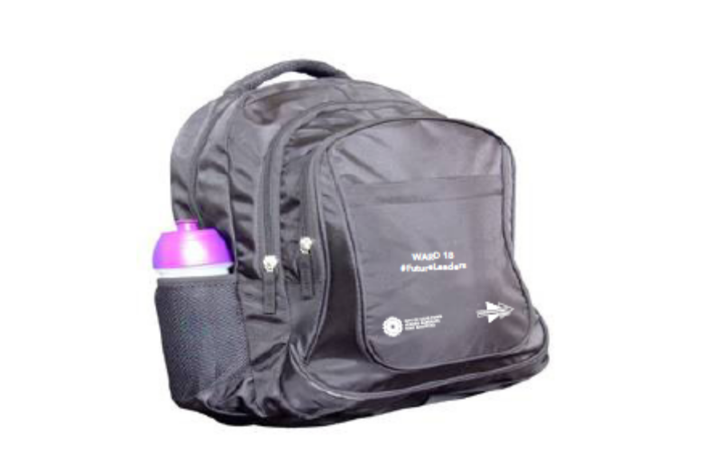

WARD 87: Ward 87 #FutureLeaders (150 back bags)
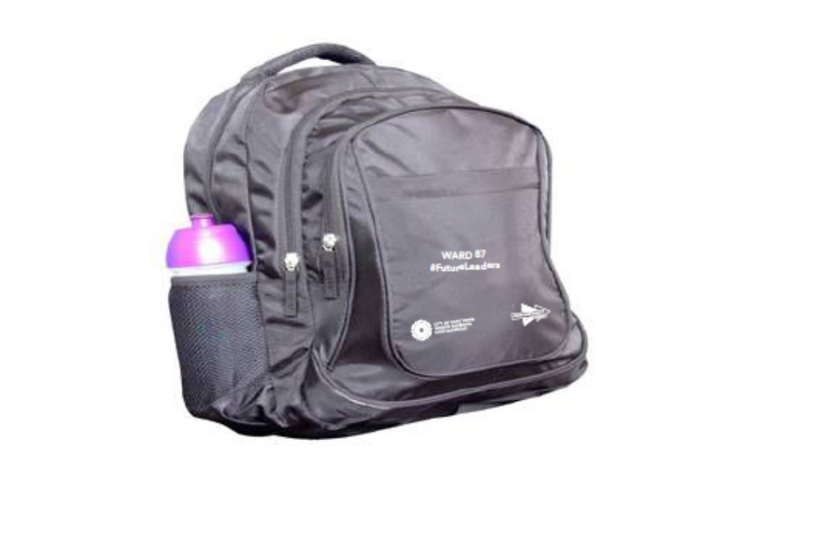
WARD 90: Ward 90 #FutureLeaders (150 back bags)

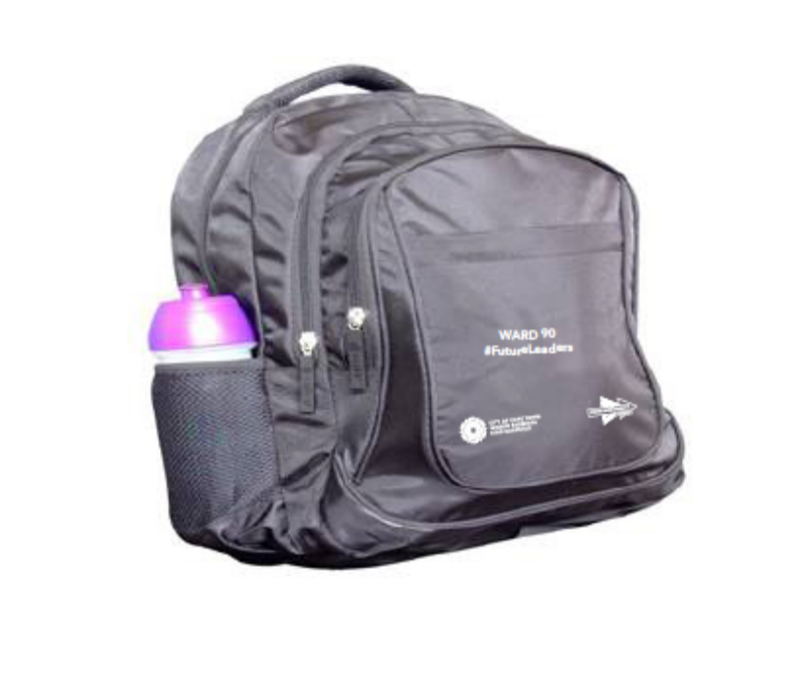
WARD 91: Ward 91 #FutureLeaders (150 back bags)

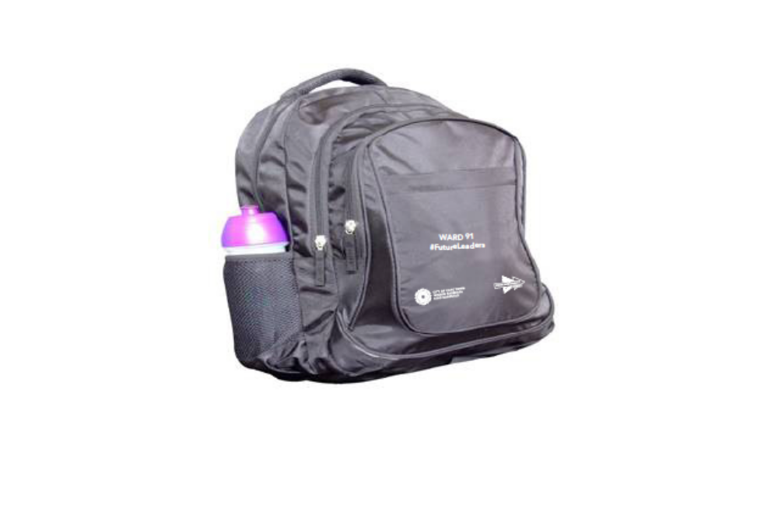

(B) QUOTATION CONDITIONS

The standard CCT quotation conditions are not reproduced in this quotation document. These quotation conditions must be downloaded from the CCT website by following this link:
http://web1.capetown.gov.za/web1/procurementportal.

By submitting a quotation suppliers warrant that they have familiarised themselves with the aforesaid quotation conditions.

ADDITIONAL QUOTATION CONDITIONS

The quotation condition listed below are in addition to those contained in the CCT standard quotation conditions and must be fully complied with:

2.1.4 Compliance with requirements of CCT SCM Policy
Delete clause 2.1.4 i) and replace with the following:
2.1.4 i) Completed Declaration – Conflict of Interest and Declaration of Bidder’s Past Supply Chain Management Practices to be provided and which does not indicate any conflict or past practises that renders the quotation non-responsive (applicable schedules to be completed and provided to CCT as and when required or when there is any change in the composition of the business entity);

2.1.6.a Local production and content
The supplier shall study the terms and conditions as stated in the Local Content Declaration / Annexure C returnable schedule.
The stipulated minimum threshold percentages for local production and content for the Textiles, Clothing, Leather and Footwear sector (“the designated sector”) is 100% and will include all sub-sectors from the applicable National Treasury Instruction Note.
Only quotes with locally produced or locally manufactured Textiles, Clothing, Leather and Footwear from local raw material or input will be considered.
If the raw material or input to be used for a specific item is not available locally, suppliers should obtain written authorisation from the Department of Trade and Industry (DTI) (Chief Director: Industrial Procurement, tel. 012 394 3927 and fax 012 394 4927) should there be a need to import such raw material or input.
A copy of the authorisation letter must be submitted together with the bid document at the closing date and time of the bid.
The CCT is obliged and must ensure that contracts for the Textiles, Clothing, Leather and Footwear sector are awarded at prices that are market related taking into account, among others, benchmark prices designated by the DTI for the sector, value for money and economies of scale. Where appropriate, prices may be negotiated with preferred bidders in accordance with provisions for Negotiation with Preferred Bidders as set out in the CCT SCM Policy.
A bid will be declared non-responsive / disqualified if the Declaration Certificate for Local Production and Content and Annex C as well as the authorisation letter referred to above (if applicable) are not submitted as part of the bid documentation at the closing date and time of the bid.
For further information relating to the local production and content legislation, suppliers may refer to website http://www.thedti.gov.za/industrial_development/ip.jsp, or may contact the Chief Director: Industrial Procurement at the DTI at telephone number (012) 394 3927 and fax (012) 394 4927, the Director: Fleet Procurement, Ms Cathrine Matidza, at telephone number (012) 394 3927 and e-mail CMatidza@thedti.gov.za, or the DTI Contact Centre no 0861 843384.

2.1.6.b Pre-qualification criteria for preferential procurement
Only those tenderers who meet the following pre-qualification criteria will be declared responsive:
- a tenderer having a stipulated minimum B-BBEE status level of contributor of level ??;
- an EME or QSE;

Clause 2.12: Quotation offer validity and withdrawal of quotations
Delete clause 2.12.1 and replace with the following clause:
2.1.2 Warrants that the quotation offer(s) remains valid, irrevocable and open for acceptance by the CCT at any time for a period of 60 days after the closing date stated on the front page of the quotation document.

Clause 3.3: Receiving / Opening of quotation submissions
Add the following clauses after clause 3.3.1
3.3.2 There will not be any public opening or announcing of these quotations.
3.3.3 All such quotations will be collated and verified as soon as possible after the closing time for submissions of quotations.
3.3.4 CCT will make available a record of the quotations and pricing schedules received upon written request.

Clause 3.9.3.4: Applicable Codes of Good Practise for Broad Based Black Econmomic Empowerement
The applicable codes for this quotation is the Generic of Good Practise for Broad Based Black Econmomic Empowerement.

(C) SPECIAL CONDITIONS OF CONTRACT

The standard CCT Special Conditions of Contract are not reproduced in this quotation document. These special conditions must be downloaded from the CCT website by following this link:
http://web1.capetown.gov.za/web1/procurementportal

By submitting a quotation suppliers warrant that they have familiarised themselves with the aforesaid Special Conditions of Contract.

ADDITIONAL SPECIAL CONDITIONS OF CONTRACT

The special conditions listed below are in addition to those contained in the CCT standard Special Conditions of Contract and must be fully complied with:

Clause 1.5: Procurement Procedures
1.5.1 The CCT intends to award Total

Clause 10.1: Delivery Period of Goods
The delivery period for this contract will be as indicated on the Pricing Schedule

Clause 11.2 (a): Amount of Public Liability Insurance
The amount required for each claim for public liability insurance for this contract is R5 million

Clause 15.2: Warranty Period
The warranty period for this contract will be

Clause 22.1: Penalty for late delivery
The penalty applicable to this contract will be R per day

(D) GENERAL CONDITIONS OF CONTRACT
(National Treasury - General Conditions of Contract (revised July 2010))

The National Treasury Conditions of Contract are not reproduced in this quotation document. These conditions of contract must be downloaded from the CCT website by following this link: http://web1.capetown.gov.za/web1/procurementportal

By submitting a quotation suppliers warrant that they have familiarised themselves with the aforesaid General Conditions of Contract.

